
6/22/2025
Eric Sanacore (eric.sanacore@snhu.edu)
CS-210-19705-M01 Programming Languages 2025 C-3 (May – Jun)
Project Three – The Corner Grocer Item-Tracking Program

The Corner Grocer needs to optimize their produce section layout. This program aims to help them achieve this by analyzing daily purchase records to understand item popularity and frequency. This C++ application (CS210_Project3_CornerGrocer_v2) processes daily sales records from an input file, calculating the frequency of each unique item while handling variations in capitalization for accurate counting. Users can interact with a menu to look up the frequency of a particular item, display a comprehensive list of all items and their counts, or view a text-based histogram. The program also automatically generates a backup file containing the collected frequency data. Input validation and error handling are implemented to provide good user experience. Some functionality was added for ‘future-proofing’; namely the use of std::getline just in case The Corner Grocer decides to add new items to the input text file that are more than word (like ‘Red Onions’ or ‘Fiji Apples’).
The following screenshots outline the program functionality:
User Menu:
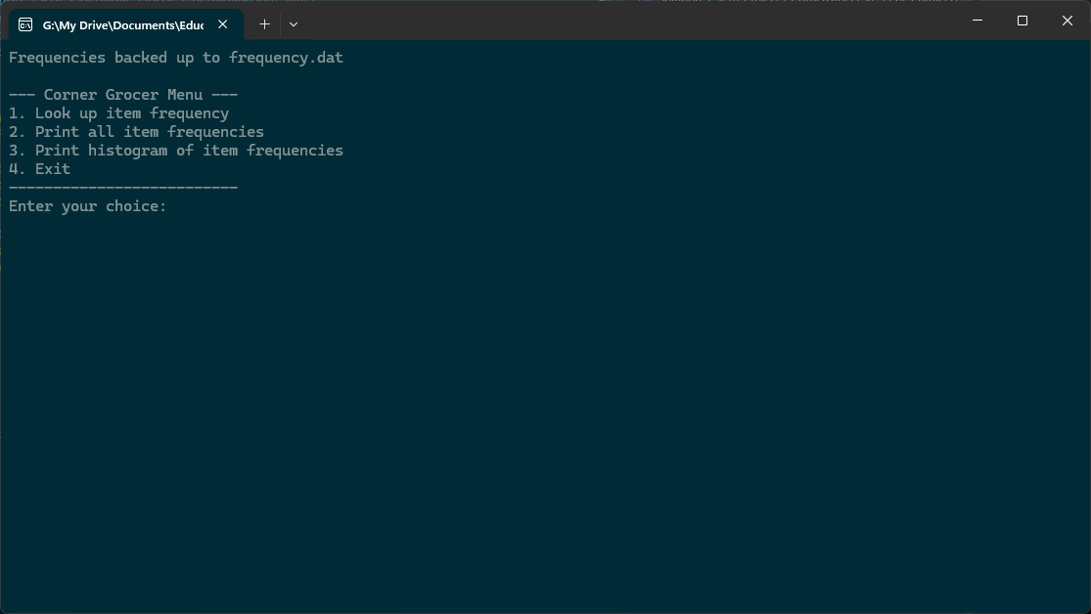
When the application is launched, the user will first be informed that the frequencies read from the input file (CS210_Project_Three_Input_File.txt) are backed up and where; in the above example “Frequencies backed up to frequency.dat”. Note that this is a plain text file that can be opened with several text-editors for reading. Below this message is the actual user menu for the application.
- Look up item frequency (this allows users to enter the name of a specific item they wish to see frequency data for)
- Print all item frequencies (this prints all item frequencies, with each item listed followed by the numerical value of the frequency. For example, ‘Apples 4’)
- Print histogram of item frequencies (this is very similar to menu option 2, except rather than a numerical value for the frequency an asterisk (*) is printed to represent each items frequency. For example, ‘Apples ****’)
- Exit (this exits the application once the user is done with their inquiry)
When the application is loaded, the cursor will be flashing immediately to the right of the line “Enter your choice”. The following screenshots will outline the respective output of each option.

Option 1: Upon entering the number ‘1’as a choice, the user receives the message “Enter the item you wish to look for:” – the screenshot below demonstrates the output when ‘Apples’ is entered:
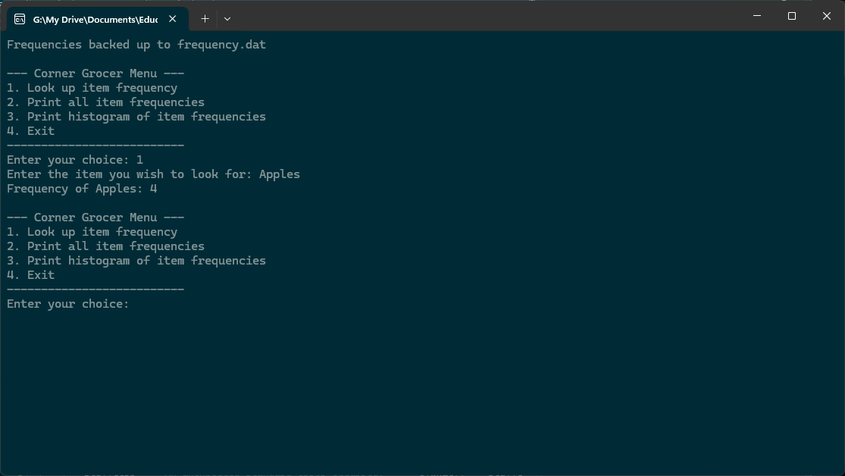

As previously mentioned, this application allows for variations in capitalization. Note that the output is the same whether the user enters ‘Apples’, ‘apples’, or some other variation like ‘appLes’ – as long as the item is still spelled correctly:
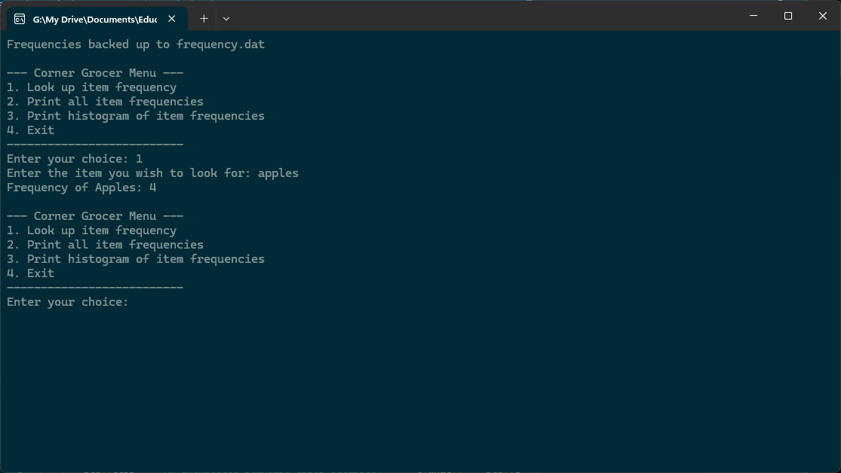
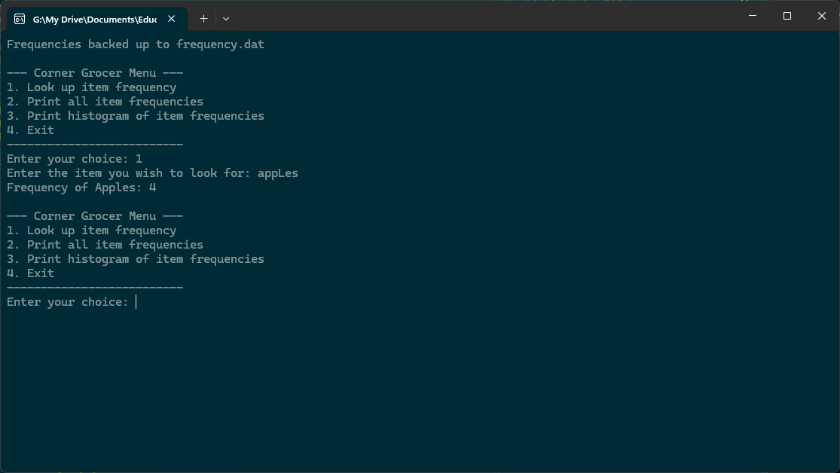
Option 2: Upon entering the number ‘2’ as a choice, the user is provided with a list of the items and the frequencies of those items, in numerical values:
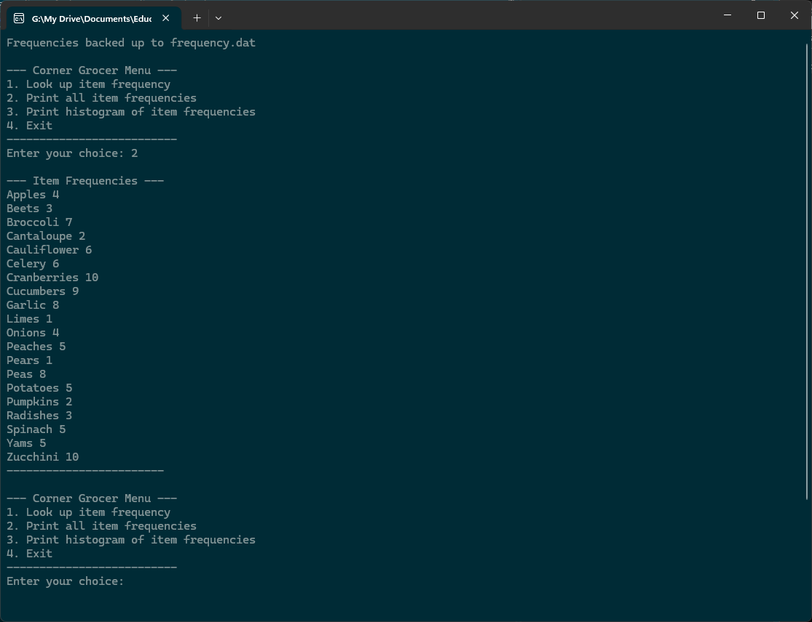

Option 3: Upon entering the number ‘3’ as a choice, the user is provided with a list of the items and the frequencies of those items in the form of a histogram, with the frequency of each item represented by an asterisk (*):
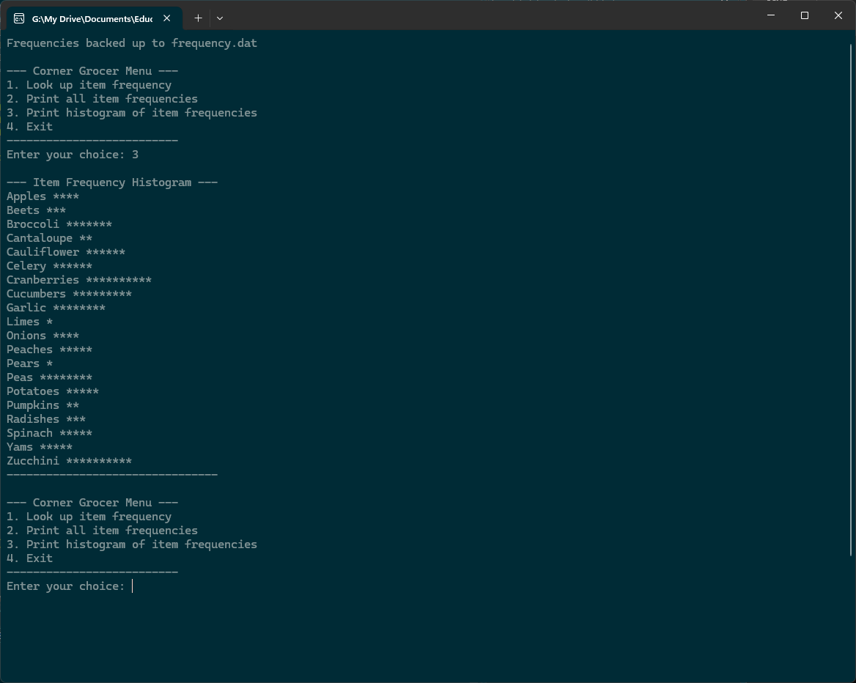

Option 4: Upon entering the number ‘4’ as a choice, the application is prompted to exit and informs the user via the message “Exiting program. Goodbye!” – the user can either close the command prompt window at this point or follow the instruction “Press any key to close this window” below the application path:
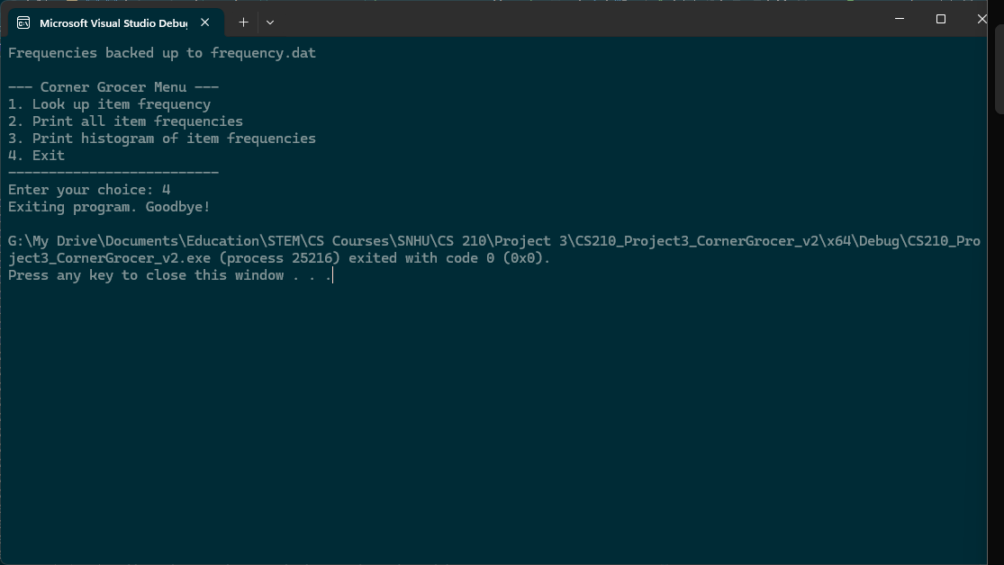

In the examples provided above, the input file “CS210_Project_Three_Input_File.txt” was used to populate the application data, a screenshot of the contents of that file is below:
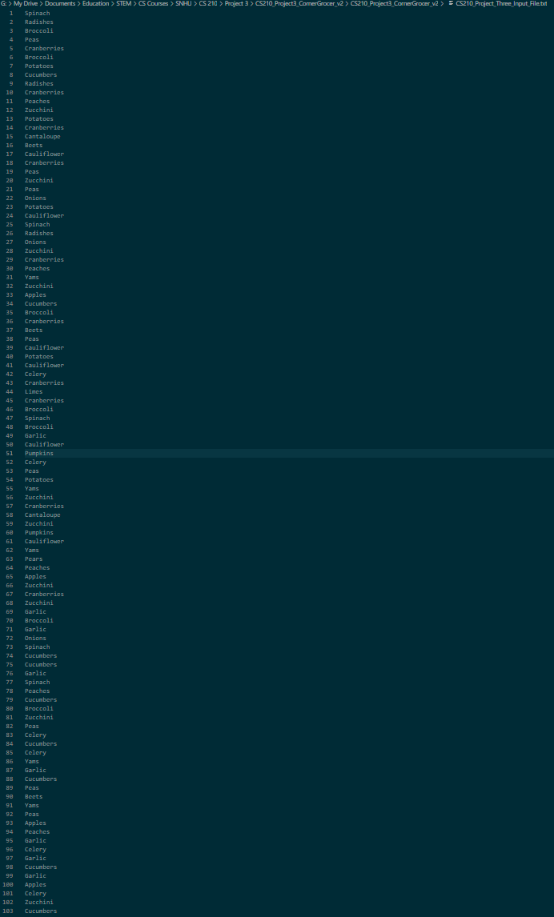
As mentioned earlier, upon launching the application a backup file ‘frequency.dat’ is generated, below is an example screenshot of the contents of that file:
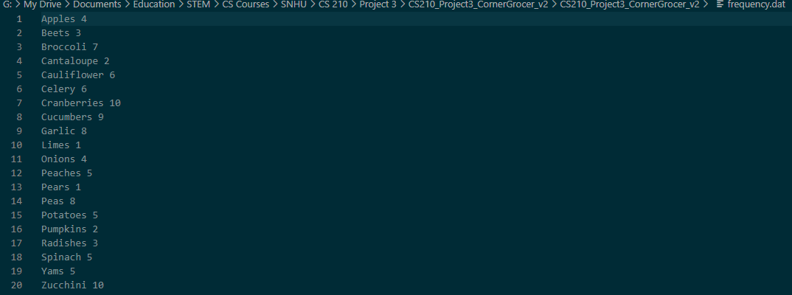
This comprehensive application successfully addresses the Corner Grocer's need for effective produce section optimization. By leveraging a robust GroceryAnalyzer class and the power of std::map for efficient, case-insensitive frequency tracking, the program offers essential insights into purchasing patterns. Its user-friendly menu, coupled with reliable input validation and error handling, ensures a smooth experience, while the automatic generation of ‘frequency.dat’ provides valuable data persistence. This solution not only fulfills the immediate requirements but also provides a modular and maintainable foundation for future enhancements to the grocer's analytical capabilities.
References:
Zybooks. (n.d.). https://learn.zybooks.com/zybook/CS-210-19705.202551-1/chapter/3/section/11
Zybooks. (n.d.). https://learn.zybooks.com/zybook/CS-210-19705.202551-1/chapter/6/section/2
Zybooks. (n.d.). https://learn.zybooks.com/zybook/CS-210-19705.202551-1/chapter/6/section/3
Zybooks. (n.d.). https://learn.zybooks.com/zybook/CS-210-19705.202551-1/chapter/11/section/4

